EXP NO:  2 | CHARACTERISTICS STUDY OF SIDE BAND POWER AND FREQUENCIES IN AM USING MATLAB
DATE:

Objectives:
i) To generate an Amplitude Modulated (AM) signal in MATLAB using specified carrier and modulating signal parameters.
ii) To determine and verify the upper sideband (USB) and lower sideband (LSB) frequencies of the AM signal using frequency spectrum analysis in MATLAB.
iii) To calculate the carrier power, sideband power, and total transmitted power of the AM signal for a given modulation index using MATLAB.
iv) To analyze the effect of varying the modulation index on sideband power distribution and overall transmission efficiency through MATLAB simulation.
Objective 1:
To generate an Amplitude Modulated (AM) signal in MATLAB using specified carrier and modulating signal parameters
PROGRAM (MATLAB CODE)
%% EXP 2 - Objective 1: AM Signal Generation & Demodulation
clc;
clear;
close all;

% Parameters
Am = 1; % Modulating signal amplitude (V)
fm = 500; % Modulating frequency (Hz)
Ac = 5; % Carrier amplitude (V)
fc = 5000; % Carrier frequency (Hz)
fs = 20 * fc; % Sampling frequency (Hz)
t = 0:1/fs:4/fm; % Time vector (4 cycles of message)

% Signal Generation
m = Am * sin(2 * pi * fm * t); % Modulating signal
c = Ac * sin(2 * pi * fc * t); % Carrier signal
mu = Am / Ac; % Modulation index (mu = 0.2)
am = Ac * (1 + mu * sin(2 * pi * fm * t)) .* sin(2 * pi * fc * t); % AM signal

% Envelope Detection
dem = abs(hilbert(am));
dem = dem - mean(dem); % Remove DC component

% Plotting
figure('Name', 'Objective 1: AM Generation and Demodulation', 'NumberTitle', 'off');

subplot(4,1,1);
plot(t, m, 'LineWidth', 1.2);
title('1. Modulating / Message Signal');
xlabel('Time (s)'); ylabel('Amplitude (V)');
grid on;

subplot(4,1,2);
plot(t, c, 'LineWidth', 1.1);
title('2. Carrier Signal');
xlabel('Time (s)'); ylabel('Amplitude (V)');
grid on;

subplot(4,1,3);
plot(t, am, 'LineWidth', 1.1);
title('3. Amplitude Modulated (AM) Signal');
xlabel('Time (s)'); ylabel('Amplitude (V)');
grid on;

subplot(4,1,4);
plot(t, dem, 'LineWidth', 1.2);
title('4. Demodulated Message Signal');
xlabel('Time (s)'); ylabel('Amplitude (V)');
grid on;

OUTPUT (GRAPH)
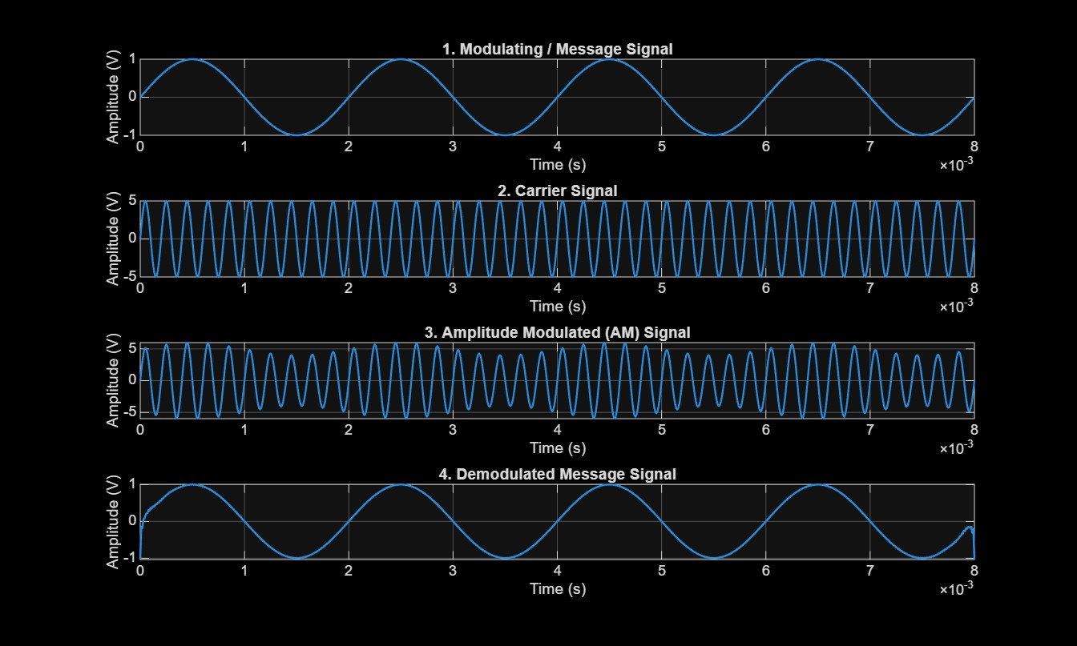

Result:
The AM signal was successfully generated and analyzed in MATLAB.
Objective 2:
To determine and verify the upper sideband (USB) and lower sideband (LSB) frequencies of the AM signal using frequency spectrum analysis in MATLAB.
PROGRAM:
%% EXP 2 - Objective 2: Sideband Frequencies Verification via FFT
clc;
clear;
close all;

% Parameters
Am = 1;
fm = 500;
Ac = 5;
fc = 5000;
fs = 20 * fc;
t = 0:1/fs:4/fm;

% Modulated Signal
mu = Am / Ac;
am = Ac * (1 + mu * sin(2 * pi * fm * t)) .* sin(2 * pi * fc * t);

% Frequency Spectrum Analysis (FFT)
N = length(am);
f = linspace(-fs/2, fs/2, N);
AM_FFT = abs(fftshift(fft(am))) / N;

% Theoretical Sideband Calculations
USB_theoretical = fc + fm;
LSB_theoretical = fc - fm;

% Display Verification
fprintf('--- Objective 2: Sideband Frequency Verification ---\n');
fprintf('Carrier Frequency (fc) : %d Hz\n', fc);
fprintf('Message Frequency (fm) : %d Hz\n', fm);
fprintf('Theoretical LSB (fc-fm): %d Hz\n', LSB_theoretical);
fprintf('Theoretical USB (fc+fm): %d Hz\n', USB_theoretical);

% Plot Frequency Spectrum
figure('Name', 'Objective 2: AM Frequency Spectrum', 'NumberTitle', 'off');
plot(f, AM_FFT, 'b', 'LineWidth', 1.2);
xlim([fc - 3*fm, fc + 3*fm]);
title('AM Double-Sided Spectrum (Carrier, LSB, USB)');
xlabel('Frequency (Hz)');
ylabel('Magnitude');
grid on;
OUTPUT GRAPH:
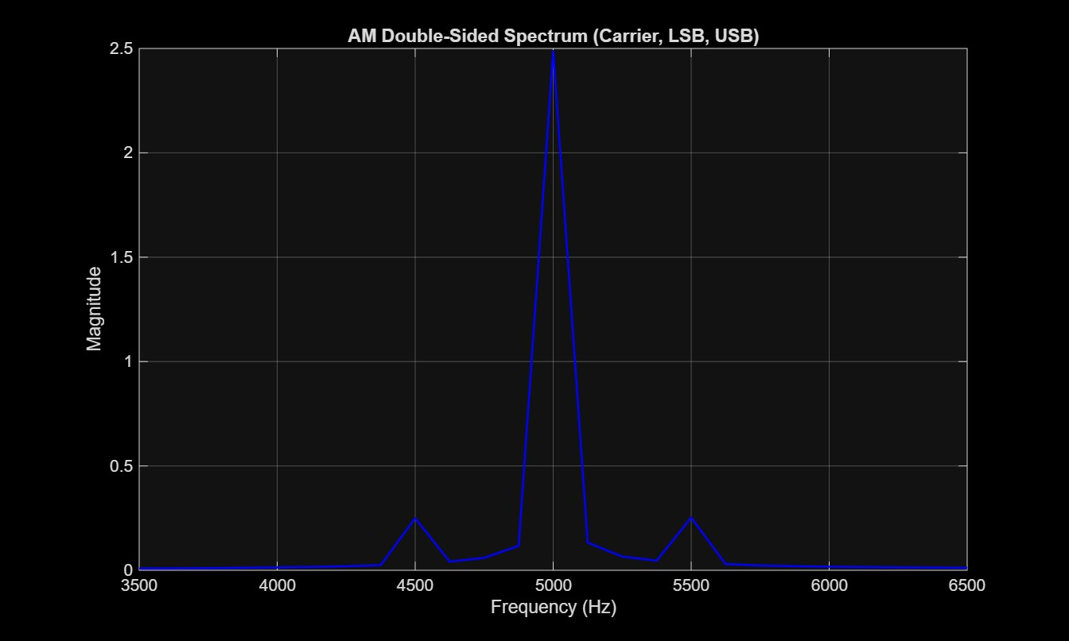
Result:
--- Objective 2: Sideband Frequency Verification ---
Carrier Frequency (fc) : 5000 Hz
Message Frequency (fm) : 500 Hz
Theoretical LSB (fc-fm): 4500 Hz
Theoretical USB (fc+fm): 5500 Hz

Objective 3:
To calculate the carrier power, sideband power, and total transmitted power of the AM signal for a given modulation index using MATLAB.
PROGRAM:
%% EXP 2 - Objective 3: Power Calculations for a Given Modulation Index
clc;
clear;
close all;

% Parameters
Ac = 5; % Carrier amplitude (V)
Am = 1; % Message amplitude (V)
R = 1; % Normalized load resistance (Ohms)
mu = Am / Ac; % Modulation index

% Theoretical Power Equations (using peak amplitude across resistance R)
Pc = (Ac^2) / (2 * R); % Carrier power
Psb = (mu^2 * Pc) / 4; % Power in one sideband (USB or LSB)
Ptsb = 2 * Psb; % Total sideband power
Pt = Pc + Ptsb; % Total transmitted power
eta = (Ptsb / Pt) * 100; % Transmission efficiency (%)

% Display Power Calculations
fprintf('--- Objective 3: Power Distribution Calculations ---\n');
fprintf('Modulation Index (mu) : %.2f\n', mu);
fprintf('Carrier Power (Pc) : %.4f W\n', Pc);
fprintf('USB Power : %.4f W\n', Psb);
fprintf('LSB Power : %.4f W\n', Psb);
fprintf('Total Sideband Power (Ptsb) : %.4f W\n', Ptsb);
fprintf('Total Transmitted Power (Pt) : %.4f W\n', Pt);
fprintf('Transmission Efficiency (eta): %.2f %%\n', eta);

% Plot Power Distribution Bar Chart
figure('Name', 'Objective 3: Power Distribution', 'NumberTitle', 'off');
bar([Pc, Psb, Psb]);
set(gca, 'XTickLabel', {'Carrier (Pc)', 'USB (P_usb)', 'LSB (P_lsb)'});
ylabel('Power (Watts)');
title(sprintf('AM Power Distribution (\\mu = %.2f)', mu));
grid on;
OUTPUT GRAPH:
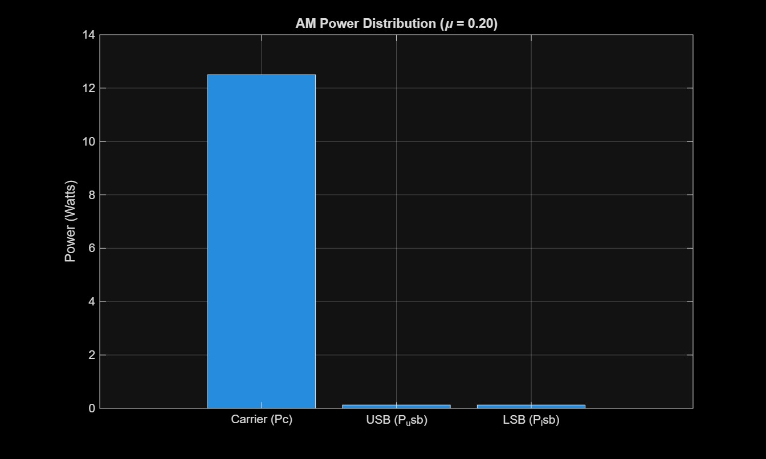
Result:
--- Objective 3: Power Distribution Calculations ---
Modulation Index (mu) : 0.20
Carrier Power (Pc) : 12.5000 W
USB Power : 0.1250 W
LSB Power : 0.1250 W
Total Sideband Power (Ptsb) : 0.2500 W
Total Transmitted Power (Pt) : 12.7500 W
Transmission Efficiency (eta): 1.96 %

OBJECTIVE 4:
To analyze the effect of varying the modulation index on sideband power distribution and overall transmission efficiency through MATLAB simulation.
PROGRAM:
%% EXP 2 - Objective 4: Sideband Power & Efficiency vs. Modulation Index
clc;
clear;
close all;

% Parameters
Ac = 5;
R = 1;
Pc = (Ac^2) / (2 * R);
mu_values = [0.2, 0.5, 0.8, 1.0];

% Initialize Arrays
P_sb_total = zeros(size(mu_values));
P_total = zeros(size(mu_values));
efficiency = zeros(size(mu_values));

fprintf('--- Objective 4: Variation of mu and Transmission Efficiency ---\n');
fprintf(' mu | Pc (W) | Ptsb (W) | Pt (W) | Efficiency (%%)\n');
fprintf('------------------------------------------------------------\n');

for i = 1:length(mu_values)
m = mu_values(i);
P_sb_total(i) = (m^2 * Pc) / 2; % Total sideband power
P_total(i) = Pc + P_sb_total(i); % Total power
efficiency(i) = (P_sb_total(i) / P_total(i)) * 100; % Efficiency

fprintf('%.2f | %8.4f | %8.4f | %8.4f | %6.2f %%\n', ...
m, Pc, P_sb_total(i), P_total(i), efficiency(i));
end

% Plot Efficiency Curve
figure('Name', 'Objective 4: Efficiency vs Modulation Index', 'NumberTitle', 'off');

subplot(2,1,1);
plot(mu_values, efficiency, '-o', 'LineWidth', 1.5, 'MarkerFaceColor', 'b');
title('Transmission Efficiency vs Modulation Index (\mu)');
xlabel('Modulation Index (\mu)');
ylabel('Efficiency (\eta %)');
grid on;

subplot(2,1,2);
plot(mu_values, P_sb_total, '-s', 'LineWidth', 1.5, 'MarkerFaceColor', 'r');
hold on;
plot(mu_values, P_total, '-^', 'LineWidth', 1.5, 'MarkerFaceColor', 'g');
legend('Total Sideband Power (Ptsb)', 'Total Power (Pt)', 'Location', 'northwest');
title('Power Variation with \mu');
xlabel('Modulation Index (\mu)');
ylabel('Power (W)');
grid on;
OUTPUT GRAPH:
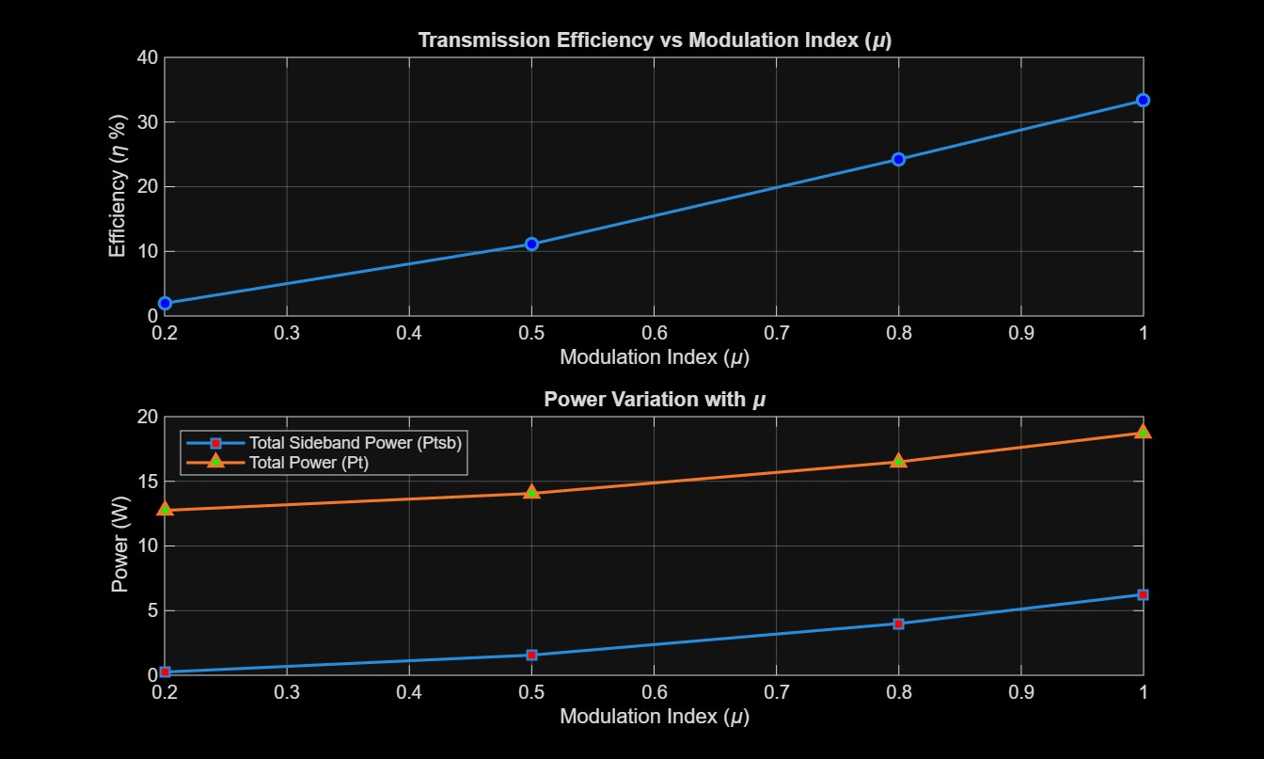
RESULT:
--- Objective 4: Variation of mu and Transmission Efficiency ---
mu | Pc (W) | Ptsb (W) | Pt (W) | Efficiency (%)
------------------------------------------------------------
0.20 | 12.5000 | 0.2500 | 12.7500 | 1.96 %
0.50 | 12.5000 | 1.5625 | 14.0625 | 11.11 %
0.80 | 12.5000 | 4.0000 | 16.5000 | 24.24 %
1.00 | 12.5000 | 6.2500 | 18.7500 | 33.33 %

